**GALGOTIAS UNIVERSITY**

**DEPARTMENT OF COMPUTER SCIENCE AND ENGINEERING**



|  |  |  |  |
| --- | --- | --- | --- |
| **SUBJECT** | **Programming for Problem Solving-C** | **PROGRAMME** | **B. Tech.** |
| **SUBJECT CODE** | **BCS0IT1003** | **BRANCH/SEMESTER** | **I** |
| **SECTION** | **24** | **FACULTY NAME** | **Mr. Atul Singh** |
| **NAME STUDENT 1** | **Aviral Gaurav** | **ENROLLMENT NO STUDNET 1** | **21SCSE1300029** |
| **NAME STUDENT 2** | **Deepansh Bhatia** | **ENROLLMENT NO STUDNET 2** | **21SCSE1011677** |
| **NAME**  **STUDENT 3** | **Neeraj Singh** | **ENROLLMENT NO STUDNET 3** | **21SCSE1011675** |
| **NAME**  **STUDENT 4** | **Abhinav Kumar Chaudhary** | **ENROLLMENT NO STUDNET 4** | **21SCSE1011615** |
| **NAME**  **STUDENT 5** | **Amit Singh** | **ENROLLMENT NO STUDNET 5** | **21SCSE1410106** |

|  |
| --- |
| **QUESTION** |

When visiting an insane asylum, I asked two inmates to give their ages. They did so, and then, to test their arithmetical powers, I asked them to add the two ages together. One gave me 44 as the answer, and the other gave 1,280. I immediately saw that the first had subtracted one age from the other, while the second person had multiplied them together. What were their ages?

|  |
| --- |
| **ALGORITHM** |

1. **Start**
2. **Declare variables a, b, c, d, e and f (Also declare the variable type)**
3. **Define the values of a, b and c**
4. **Add value of a, b and c**
5. **Store the output of step 4 in d**
6. **Put the conditions for d (if and else condition)**
7. **Ask the user to enter the values of a b c**

**(Then program will check the condition of d)**

1. **Print e and f (according to condition)**
2. **Stop**

|  |
| --- |
| **FLOWCHART** |

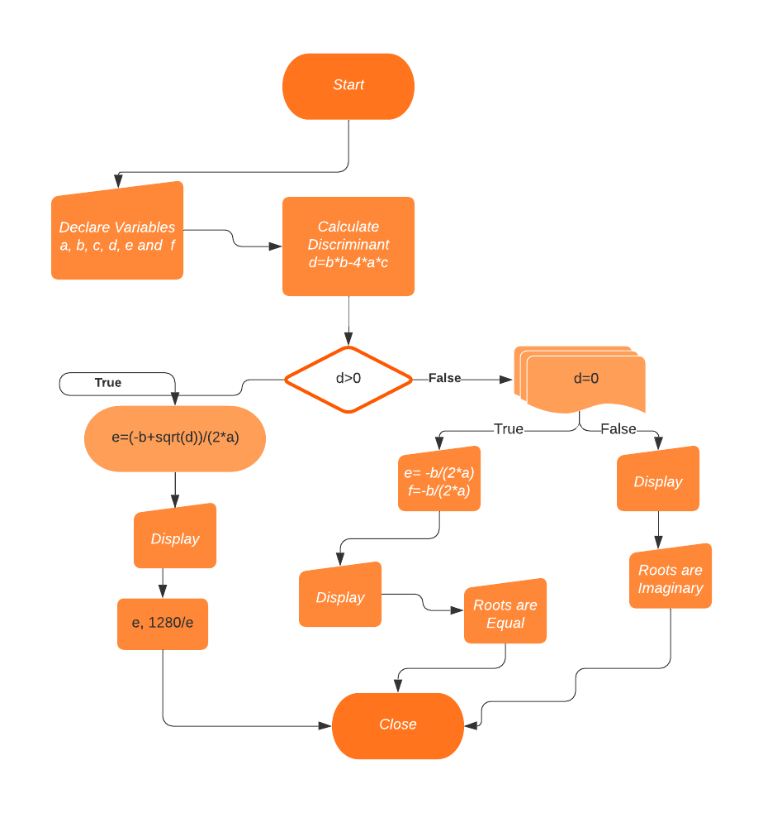

|  |
| --- |
| **C PROGRAM** |

**#include<stdio.h>**

**#include<math.h>**

**int main()**

**{**

**printf("Let the age of the 1st inmate is x\n");**

**printf("and let the age of the second inmate is y\n");**

**printf("First has substracted the ages so the**

**equation:\n    x-y=44   ......(1)\n");**

**printf("Second has multiplied the ages so the**

**equation:\n    x*y=1280    ......(2)\n");**

**printf("On Simplifying the both equations we**

**get:\n    x*x-44x-1280=0     ........(3)\n");**

**float a,b,c,d,e,f;**

**printf("Enter the value of coefficient a, b and c from the**

**equation (3)\n=");**

**scanf("%f %f %f", &a, &b, &c);**

**d=b*b-4*a*c;**

**e=sqrt(d);**

**if (d>0)**

**{**

**e=(-b+sqrt(d))/(2*a);  // applying Sridharacharya Formula**

**// ignoring (-b-sqrt(d))/(2*a) because age cannot be negative**

**printf("\n\n");**

**printf("The Age of first inmate is = %f\n",e);**

**printf("The Age of second inmate is = %f\n",1280/e);**

**}**

**else**

**if (d==0)**

**{**

**e=-b/(2*a);**

**f=-b/(2*a);**

**printf("The root are equal = %f",e,f);**

**}**

**else**

**printf("Roots are imaginary");**

**return 0;**

**}**

|  |
| --- |
| **OUTPUT** |

**Let the age of the 1st inmate is x**

**and let the age of the second inmate is y**

**First has subtracted the ages, so the equation:**

**x-y=44 ......(1)**

**Second has multiplied the ages, so the equation:**

**x*y=1280 ......(2)**

**On Simplifying the both equations we get:**

**x*x-44x-1280=0 ........(3)**

**Enter the value of coefficient a, b and c from the equation (3)**

**=1 -44 -1280**

**The Age of first inmate is = 64.000000**

**The Age of second inmate is = 20.000000**

|  |
| --- |
| **PROGRAM IN VISUAL CODE STUDIO** |

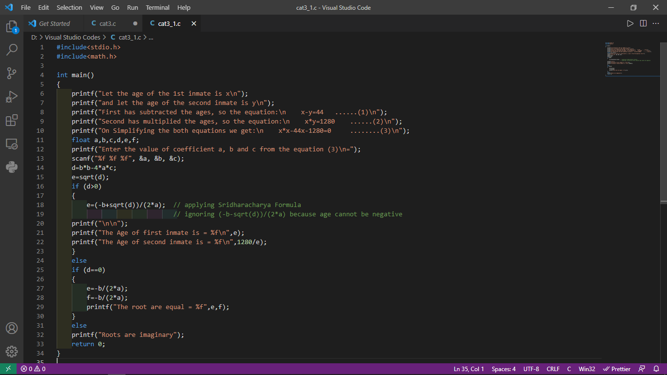

|  |
| --- |
| **PROGRAM OUTPUT** |

